Canine Puberty
- Normal puberty can occur at 6-24 months.
- Larger dogs tend to reach puberty at an older age than smaller dogs.
- First estrus tends to be irregular.
  - Do not base fertility on what happens during the first heat.
  - Split heats are common during the first estrus.
    - The bitch bleeds, stops bleeding and then returns to heat around 6 weeks later. Fertility is normal for these heats, however.
  - Do not breed on first heat. Breeding on the first heat may increase the risk of dystocia.
- Delayed puberty is rare in the bitch.
- Nutritionally delayed puberty has a poor prognosis for future fertility.
- Induction of the first estrus can sometimes be hastened by housing the bitch with a kennelmate that is in proestrus.
Interestrous intervals
Interestrus consists of diestrus (60 days) plus anestrus (a variable time).
- Average duration is 7 months.
- G. Shepherd dogs average about 6.5 months interestrus.
- Dachshunds average about 8.3 months interestrus.
- Basenjis average about 12 months interestrus.
- Therefore, larger dogs tend to have shorter interestrus intervals than small dogs (contrary to popular opinion)
- The variation of the interestrus interval within a bitch was actually found to be greater than that between bitches in a research study done by Dr. Guy Bouchard.
- Interestrus tends to become longer as bitches are greater than 8 years old.
Canine Seasonality
There seemed to be a greater chance of bitches coming into estrus during the summer and winter in one study, but.....
- The study concluded that there was a 1/12 chance of a bitch coming into estrus in any one month.
- A study from Sweden indicated that most matings took place during winter, and the fewest during summer
  - Consequently, most whelpings occurred during the winter and spring seasons.
  - These were planned breedings however

Normal Canine Cycle
- Stages of the cycle are anestrus, proestrus, estrus, and diestrus.
Anestrus

- Anestrus is not the same as interestrus. Anestrus is a variable time after diestrus. Interestrus (diestrus + anestrus) averages 5 - 7 months.
- Anestrus lasts 90 - 150 days (anestrus does not include diestrus).
- Anestrus is a time of mandatory endometrial repair that has been documented in Beagles.
Anestrus Endometrial Repair
- The endometrium is being 'repaired' after the progesterone effects during diestrus for the preceding 60 days.
- True anestrus lasts 90 -150 days post whelping, or post diestrus.
- Interestrus (anestrus + diestrus) lasts 150 - 210 days after the last estrus.
- Fertility is low if at least 90 day anestrus (or a 150 interestrus interval) is not attained. This is because the uterus has not repaired enough to maintain pregnancy. (If interestrus is too short, anestrus can be extended using mibolerone or megestrol acetate, but this will be covered later.)
Anestrus 'events'
- The male shows no sexual interest in the female.
- The female shows no sexual interest in the male.
- The vulva appears normal. It is not swollen or edematous.
- The vaginal cytology has very few cells and they are noncornified.
- The vaginal wall is very thin and appears pale on vaginal speculum examination.
- Progesterone is at baseline concentrations (<1 ng/ml). Even spayed bitches run basal levels of progesterone. This baseline progesterone is probably of adrenal origin.
- Prolactin secretion by the pituitary may promote anestrus, because prolactin inhibitors can be used to terminate anestrus (i.e. induce estrus).
Termination of anestrus
(FYI only)
- Increased pulse frequency of LH is seen late in anestrus.
- FSH is elevated late in anestrus, but follicles may actually be selected for the next cycle at this time. This is really not known very well. Inhibin may inhibit FSH, but it has not been documented in the bitch.
Proestrus

Proestrus 'events'
- Proestrus averages 9 days in duration, but may last from 3-17 days.
- Males are interested in the female.
- Females are not interested in the males.
- The vulva is swollen because of estrogen secretion by the growing follicles.
- There is serosanguinous discharge from the vulva that results from diapedesis of RBCs through uterine vessels.
- The vaginal mucosa appears smooth because estrogen causes water retention.
- LH has an increased frequency.
- FSH is suppressed.
- Estrogen comes from the growing follicles and peaks at end of proestrus. It is actually the decline in estrogen at the end of proestrus that causes the bitch to show clinical signs of estrus.
- Testosterone is relatively high at the end of proestrus. This may result from a 'backup' in estrogen synthesis. This may result in some masculine behavior by the bitch, such as mounting other dogs.
Proestrus vaginal cytology
    - Parabasal cells
    - Superficial cells increase. Cornification increases approximately 10%/day until about 100% of the cells are cornified.
    - May or may not see RBCs
    - May see a bloody discharge, yet see no RBC's on the vaginal smear.
    - WBC, mostly PMNs may be present.
Proestrus vaginoscopy
    - The mucosa is glistening.
    - There are rounded edges to mucosa because of the water retention in the cells.

Estrus
Estrus 'events'
    - Estrus averages 9 days in duration, but can be as short as 3 days or as long as 21 days.
    - The male and female are both interested in each other.
    - The bitch will 'flag' her tail, as if allowing access to the vulva.

Click to see 'Flagging'
    - The estrous behavior results from the estrogen that peaked during proestrus abruptly declining. If this decline is prevented (i.e. giving exogenous estrogen), then the bitch will not show signs of estrus.
Estrus Vaginal cytology
    - The smear is very cellular. Many more cells than in anestrus.
    - Greater than 90% of the cells are cornified. Most of the cells are usually anuclear cells.
    - The PMN's are gone because the hyperplastic vaginal wall is too thick for them to cross the mucosa.
    - RBC's are generally gone.
    - The background of the smear becomes very clean.
    - The cells may slough off on sheets as the end of estrus approaches.
Vaginoscopy
- The vulva and vaginal epithelium appear to wrinkle because the decreased estrogen results in water loss of the cells.
Ovulation
    - LH peaks about 24-48 hours into estrus and is caused by the estrogen peak during proestrus. The LH surge causes ovulation of the ovarian follicles.
    - LH has a very short peak duration and must be assayed every day in order to detect the peak rise. An in-house test is available to detect the LH peak, but you must test daily to identify the surge.
    - Ovulation occurs 24-48 hours after LH surge (day 3-4 of estrus)
    - Ovulation takes about takes 24 hours for all oocytes to be ovulated. A '2N' oocyte is ovulated and the oocyte must undergo reduction division, which takes 2-3 days, before the oocyte is ready for fertilization. During this time the polar body extruded (a 1N 'nuclei' of chromosome).
    - If it is not fertilized, the oocytes die 3-4 days post maturation (5-6 days post ovulation).
    - The fertile period of breeding is generally recommended as the 3rd to the 5th days of estrus, or every other day of estrus.
    - Ultrasound is poor at determining ovulation because the follicles do not appear to luteinize, they remain anechoic.
Progesterone during estrus
    - Progesterone starts to rise during estrus. The initial rise usually coincides with the LH peak.
    - The preovulatory rise in progesterone is caused by estrual luteinization of follicles and a 'backup' in progesterone from the estrogen synthesis.
    - The progesterone rise that coincides with the LH rise can be measured with an ELISA kit and be used to time fertile period.
    - Since progesterone starts to rise coincidentally with the LH peak, when estrus ends the progesterone is already greatly elevated over baseline.
Androstenedione
    - Concentrations rise
    - Luteal origin ?
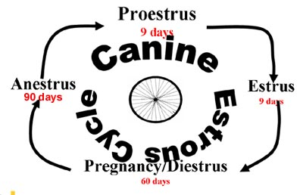
Diestrus
Diestrus is the time of progesterone dominance. The hormonal events of diestrus can be, for learning sake, identical in pregnant and non-pregnant bitches
      - This is not really true.
      - Progesterone is lower overall in non-pregnant bitches
      - Prolactin is lower in bitches that do not show overt pseudopregnancy.
    - Diestrus in the non-pregnant bitch could be called covert pseudopregnancy, since progesterone remains elevated, but there are no signs of pregnancy.
Diestrus 'events'
    - The bitch refuses male's advances. This refusal is quite variable in when it occurs.
    - The duration of diestrus is about 60 days, whether or not the bitch is bred and/or pregnant.
Diestrus vaginal cytology
      - There is an abrupt change from the 100% to less than 50% cornification on the first day of diestrus.
      - The PMN's return to clean up all the sloughed cells and debris.
      - Intermediate cells return as well as 'metestrum' cells and foam cells.
Diestrus progesterone
    - Progesterone comes from the corpora luteal
    - Promotes endometrial glands development.
    - Promotes mammary alveolar glands.
    - Antagonizes estrogen.
    - Progesterone rises throughout diestrus.
    - Progesterone peaks at 15-30 days of diestrus at 15-80 ng/ml.
    - Progesterone is overall lower in nonpregnant bitches, but there is too much overlap to use lower progesterone concentration as a pregnancy test.
    - Progesterone declines to less than 1 ng/ml 60-100 days after the first day of diestrus.
    - Progesterone production is dependent upon LH and prolactin production by anterior pituitary.
Prolactin in diestrus
    - Luteotropic
    - It is higher in pregnant bitches than in non-pregnant bitches.
    - Rises with fall of progesterone in pregnant bitches
    - Higher in overtly pseudopregnant bitches than non-pregnant bitches without overt pseudopregnancy.
    - Causes mammary development.
  - 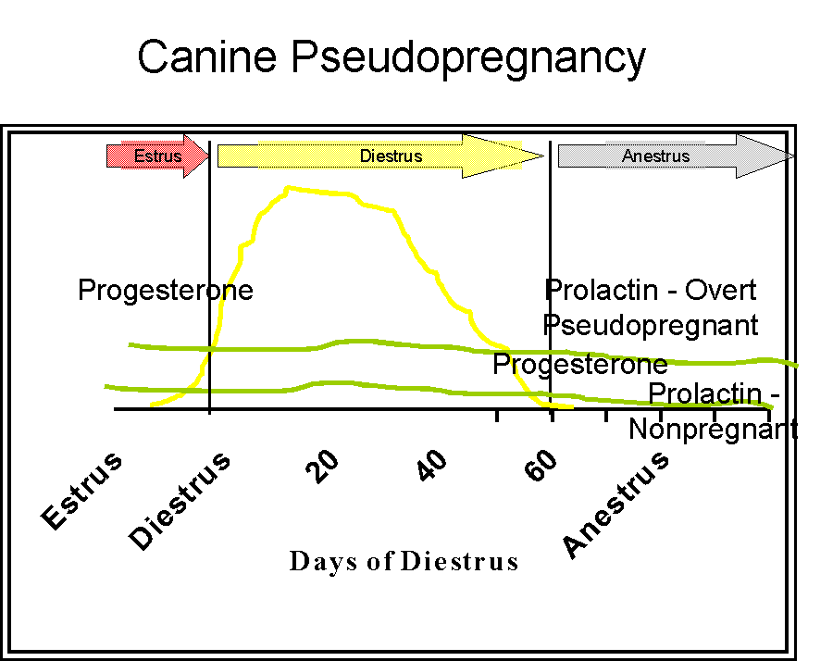
Cessation of diestrus
    - No known luteolytic PGF secreted from the uterus in non-pregnant bitches.
    - Hysterectomy has no effect on the luteal lifespan.
    - Prostaglandins are luteolytic in the bitch as early as 5 days after the beginning of diestrus. The dose is usually cited as 0.1 - 0.25 mg/kg SID-TID for 3-5 days, but progesterone must be followed to ensure luteolysis.

