Artificial Insemination

  - Lec. 2 Role of sertoli cell
  - Lec. 3 Hormonal Control of spermatogensis

Prof. Dr. Najlaa S. Ibrahim

Role of Sertoli cells
Sertoli cell
At all stages of differentiation, the spermatogenic cells are in close contact with Sertoli cells which are thought to provide structural and metabolic support to the developing sperm cells. A single Sertoli cell extends from the basement membrane to the lumen of the seminiferous tubule, although the cytoplasmic processes are difficult to distinguish at the light microscopic level.
Sertoli cells serve a number of functions during spermatogenesis, they support the developing gametes in the following ways:
- Maintain the environment necessary for development and maturation, via the blood-testis barrier
- Secrete substances initiating meiosis
- Secrete supporting testicular fluid
- Secrete androgen-binding protein (ABP), which concentrates testosterone in close proximity to the developing gametes
  - Testosterone is needed in very high quantities for maintenance of the reproductive tract, and ABP allows a much higher level of fertility
- Secrete hormones affecting pituitary gland control of spermatogenesis, particularly the polypeptide hormone, inhibin
- Phagocytose residual cytoplasm left over from spermiogenesis
- They release Antimullerian hormone which prevents formation of the Müllerian Duct / Oviduct.
- Protect spermatids from the immune system of the male, via the blood-testis barrier

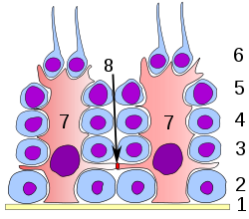
Labelled diagram of the organisation of Sertoli cells (red) and spermatocytes (blue) in the testis. Spermatids which have not yet undergone spermiation are attached to the lumenal apex of the cell

Germinal epithelium of the testicle.
1: basal lamina 2: spermatogonia 3: spermatocyte 1st order 4: spermatocyte 2nd order
5: spermatid 6: mature spermatid 7: Sertoli cell 8: tight junction (blood testis barrier)

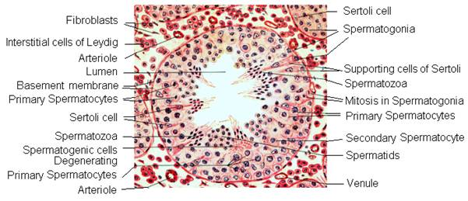

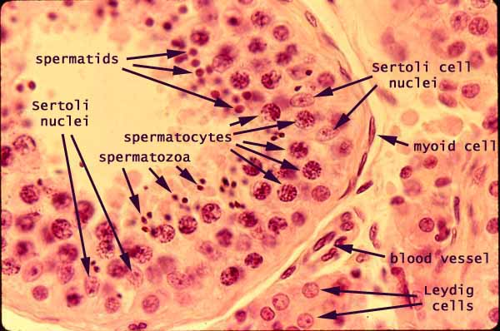

Histological section through testicular parenchyma

Influencing factors
The process of spermatogenesis is highly sensitive to fluctuations in the environment, particularly hormones and temperature. Testosterone is required in large local concentrations to maintain the process, which is achieved via the binding of testosterone by androgen binding protein present in the seminiferous tubules. Testosterone is produced by interstitial cells, also known as Leydig cells, which reside adjacent to the seminiferous tubules.
Seminiferous epithelium is sensitive to elevated temperature in humans and some other species, and will be adversely affected by temperatures as high as normal body temperature. Consequently, the testes are located outside the body in a sack of skin called the scrotum. The optimal temperature is maintained at 2 °C (man)–8 °C (mouse) below body temperature. This is achieved by regulation of blood flow[ and positioning towards and away from the heat of the body by the cremasteric muscle and the dartos smooth muscle in the scrotum.
Dietary deficiencies (such as vitamins B, E and A), anabolic steroids, metals (cadmium and lead), x-ray exposure, dioxin, alcohol, and infectious diseases will also adversely affect the rate of spermatogenesis. In addition, the male germ line is susceptible to DNA damage caused by oxidative stress, and this damage likely has a significant impact on fertilization and pregnancy.

Hormonal control
Hormonal control of spermatogenesis varies among species. In humans the mechanism is not completely understood, however it is known that initiation of spermatogenesis occurs at puberty due to the interaction of the hypothalamus, pituitary gland and Leydig cells. If the pituitary gland is removed, spermatogenesis can still be initiated by follicle stimulating hormone and testosterone.
Follicle stimulating hormone stimulates both the production of androgen binding protein by Sertoli cells, and the formation of the blood-testis barrier. Androgen binding protein is essential to concentrating testosterone in levels high enough to initiate and maintain spermatogenesis, which can be 20–50 times higher than the concentration found in blood. Follicle stimulating hormone may initiate the sequestering of testosterone in the testes, but once developed only testosterone is required to maintain spermatogenesis. However, increasing the levels of follicle stimulating hormone will increase the production of spermatozoa by preventing the apoptosis of type A spermatogonia. The hormone inhibin acts to decrease the levels of follicle stimulating hormone. Studies from rodent models suggest that gonadotropin hormones (both LH and FSH) support the process of spermatogenesis by suppressing the proapoptotic signals and therefore promote spermatogenic cell survival
The Sertoli cells themselves mediate parts of spermatogenesis through hormone production. They are capable of producing the hormones estradiol and inhibin. The Leydig cells are also capable of producing estradiol in addition to their main product testosterone.

Peritubular myoid cells in the testis: their structure and function.
Peritubular myoid cells, surrounding the seminiferous tubules in the testis, have been found in all mammalian species, but their organization in the peritubular interstitial tissue varies by species. In laboratory rodents, including rats, hamsters and mice, only one layer of myoid cells is seen in the testis. The cells in these animals are joined by junctional complexes as are epithelial cells. On the other hand, several cellular layers exist in the lamina propria of the seminiferous tubule in the human and some other animals. Myoid cells contain abundant actin filaments which are distributed in the cells in a species-specific manner. In the rat, the filaments within one myoid cell run both longitudinally and circularly to the long axis of the seminiferous tubule, exhibiting a lattice-work pattern. The arrangement of the actin filaments in the cells changes during postnatal development, and the disruption of spermatogenesis, such as cryptorchidism, seems to affect further the arrangement of the filaments. Other cytoskeletal proteins, including myosin, desmin/vimentin and alpha-actinin, are also found in the cells. Myoid cells have been shown to be contractile, involved in the transport of spermatozoa and testicular fluid in the tubule. Several substances (prostaglandins, oxytocin, TGF beta, NO/cGMP) have been suggested to affect the contraction of the cell, though the mechanisms of the contraction are still unknown. Recent in vitro studies have demonstrated that the cells secrete a number of substances including extracellular matrix components (fibronectin, type I and IV collagens, proteoglycans) and growth factors (PModS, TGF beta, IGF-I, activin-A). Some of these substances are known to affect the Sertoli cell function. Furthermore, it has been reported that myoid cells contain androgen receptors and are involved in retinol processing. Considering all this, it is evident that peritubular myoid cells not only provide structural integrity to the tubule but also take part in the regulation of spermatogenesis and the testicular function. Their precise roles, however, remain to be solved.
Peritubular myoid cells form a single layer of flattened cells which surrounds the Sertoli cells, circumscribing the testis cords. Their main functions include structural regulation of the forming testis cords, in conjunction with Sertoli cells, and promotion of the movement of mature sperm through the seminiferous tubules of the adult testis for export to the seminal vesicles, a function mediated by their smooth muscle-like character.
Notes :
Peritubular myoid cells represent the only cell type in the testis for which no counterpart has been identified in the ovary. This might be due to their origin from immigrating cells from the mesonephros, which only occurs in an XY gonad after the expression of Sry.
The SRY gene provides instructions for making a protein called the sex-determining region Y protein. This protein is involved in male sexual development, which is usually determined by the chromosomes an individual has. The SRY gene is found on the Y chromosome. The sex-determining region Y protein produced from this gene acts as a transcription factor, which means it attaches (binds) to specific regions of DNA and helps control the activity of particular genes. This protein starts processes that cause a fetus to develop male gonads (testes) and prevent the development of female reproductive structures (uterus and fallopian tubes).
