University of Baghdad
College of Veterinary Medicine
Dept. of Vet. Public Health/ Meat Hygiene Division
Meat Hygiene Course/ 5th. Year
2015-2016

Theory Lecture #: 2nd.Semester
What is Meat Hygiene?
Meat: is the common term used to describe the edible portion of animal tissues.
Hygiene: (which comes from the name of the Greek goddess of health, Hygieia), is a set of practices performed for the preservation of Health
Meat hygiene make sure that meat is safe, and that its production and processing satisfies hygiene laws.

- Meat hygiene could involve:

- Inspecting the hygiene in slaughterhouses, cutting plants, factories and cold stores
- Checking animal welfare conditions
- Inspecting live animals, game or poultry for any signs of disease
- Carrying out post mortems on diseased animals
- Checking meat transportation conditions
- Making sure that unfit meat is destroyed properly
- Recording the findings from your inspections
- Recommending any improvements that need to be made
- Making sure that improvements are carried out.

Definition of meat for human consumption.

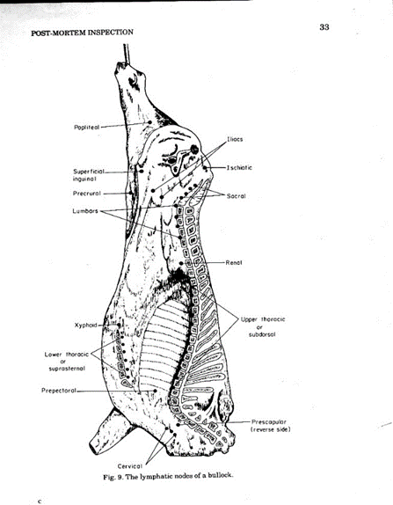

- Meat is the common term used to describe the edible portion of animal tissues .In this context, meat can be defined as “the muscle tissue of slaughter animals”.
- Meats are often classified by the type of animal from which they are taken.
1. Red meat refers to the meat taken from mammals;
2. White meat refers to the meat taken from fowl;
3. Seafood refers to the meat taken from fish and shellfish;
4. Game refers to meat taken from animals that are not commonly domesticated.
- In addition, most commonly consumed meats are specifically identified by the live animal from which they come.
1. Beef refers to the meat from cattle,
2. Veal from calves,
3. Lamb from young sheep,
4. Mutton from sheep older than two years.

MEAT, FAT AND OTHER EDIBLE CARCASS PARTS (Types, structure, and biochemistry)
- Meat, fat and other carcass parts are mainly derived from the domesticated animal species cattle and poultry and to a lesser extend from buffaloes, sheep and goats.
- In some regions other animal species such as camels, horses and game animals are used as meat animals but play only a minor role in meat processing.
- In this context, meat can be defined as : “the muscle tissue of slaughter animals”.

Meat inspection
The objectives of meat inspection programme are :
- To ensure that only apparently healthy, physiologically normal animals are slaughtered for human consumption and that abnormal animals are separated and dealt with accordingly.
- To ensure that meat from animals is free from disease, wholesome and of no risk to human health.
- Safe from harmful chemical and drug residues, and capable of being converted into wholesome product for the consumer.
- Notifiable diseases may be detected at ante mortem inspection ( e.g. Anthrax ,FMD. TB, Brucellosis….cet.)

These objectives are achieved by:
- Antemortem Inspection.
- Postmortem inspection procedures.
- Hygienic dressing with minimum contamination.
- Whenever appropriate the Hazard Analysis Critical Control Point (HACCP) principles should be used.

- The term ante-mortem means “before death.”
- Ante-mortem inspection is the inspection of live animals before they are slaughtered.
- In any abattoir, all livestock presented for slaughter must receive ante-mortem inspection.
- Ante-mortem inspection of live animals is a screening process :
- to remove obviously diseased animals from the food supply prior to slaughter .
- to identify animals that require a more extensive postmortem examination.
- It is the first line of defense in protecting the public from potentially harmful meat products.
- Those animals that exhibit abnormal signs must be withheld from normal slaughter and segregated for closer examination.

Authority
- The authority for conducting ante-mortem inspection rests within the Veterinary Inspectors assigned to each abattoir by the Ministry of Agriculture.
- Veterinary Inspectors are authorized to examine and inspect livestock prior to slaughter.
- She/he should make sure that animals are denied access to feed 12 hrs. before slaughter.
- The Veterinary Inspectors are obliged to accept for slaughter only those animals which are capable of producing products that are acceptable for use as human food
- Veterinary inspectors should have the required training, knowledge, skills and ability to conduct ante-mortem inspection procedures.

The major objectives of ante mortem inspection are as follows:
- to screen all animals destined to slaughter.
- to ensure that animals are properly rested and that proper clinical information, which will assist in the disease diagnosis and judgment, is obtained.
- to reduce contamination on the killing floor by separating the dirty animals and condemning the diseased animals if required by regulation.
- to ensure that injured animals or those with pain and suffering receive emergency slaughter and that animals are treated humanely.
- to identify reportable animal diseases to prevent killing floor contamination.
- to identify sick animals and those treated with antibiotics, chemotherapeutic agents, insecticides and pesticides.
- to require and ensure the cleaning and disinfection of trucks used to transport livestock.
- Both sides of an animal should be examined at rest and in motion.
- Ante mortem examination should be done within 24 hours of slaughter and repeated if slaughter has been delayed over a day.

A/M Inspection Card
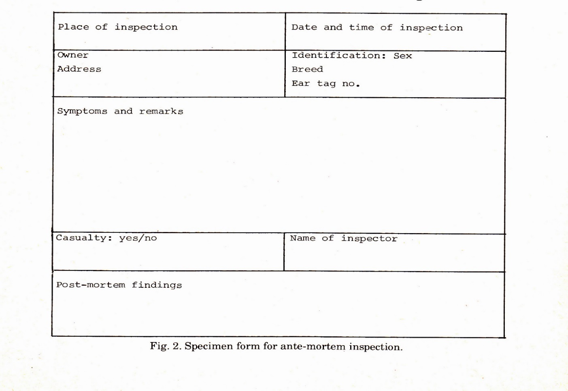
Ante-mortem inspection methodology
- The disease and management history should be recorded and reported on an A/M inspection card. Other information should include:
- 1.Owner's name
- 2.The number of animals in the lot and arrival time
- 3.Species and sex of the animal
- 4.The time and date of ante mortem inspection
- 5.Clinical signs and body temperature if relevant
- 6.Reason why the animal was held
- 7.Signature of inspector

Some of the abnormalities which are checked on antemortem examination include:
- 1.Abnormalities in respiration
- 2.Abnormalities in behaviour
- 3.Abnormalities in gait
- 4.Abnormalities in posture
- 5.Abnormalities in structure and conformation
- 6.Abnormal discharges or protrusions from body openings
- 7.Abnormal colour
- 8.Abnormal odour

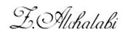
Dr. Zuhair Ahmed
MSc & PhD
Meat Science & Hygiene

